

For T he LADY Cond escending

A Recent & Moderne

H O U S E K E E P I N G

B E I N G

An A C C O M P T diverting and Wonder-full of a House Well-Kept by a Curiu{ Guest – a' S P Y R I T ' of unplumbed Dimension and Convenient Providense – Apparated Un-Natural & Instaling him-{elf from an F I S S U R E Atomick in the Skirt of the Kitchin Wall two Year{ before now thu{ -
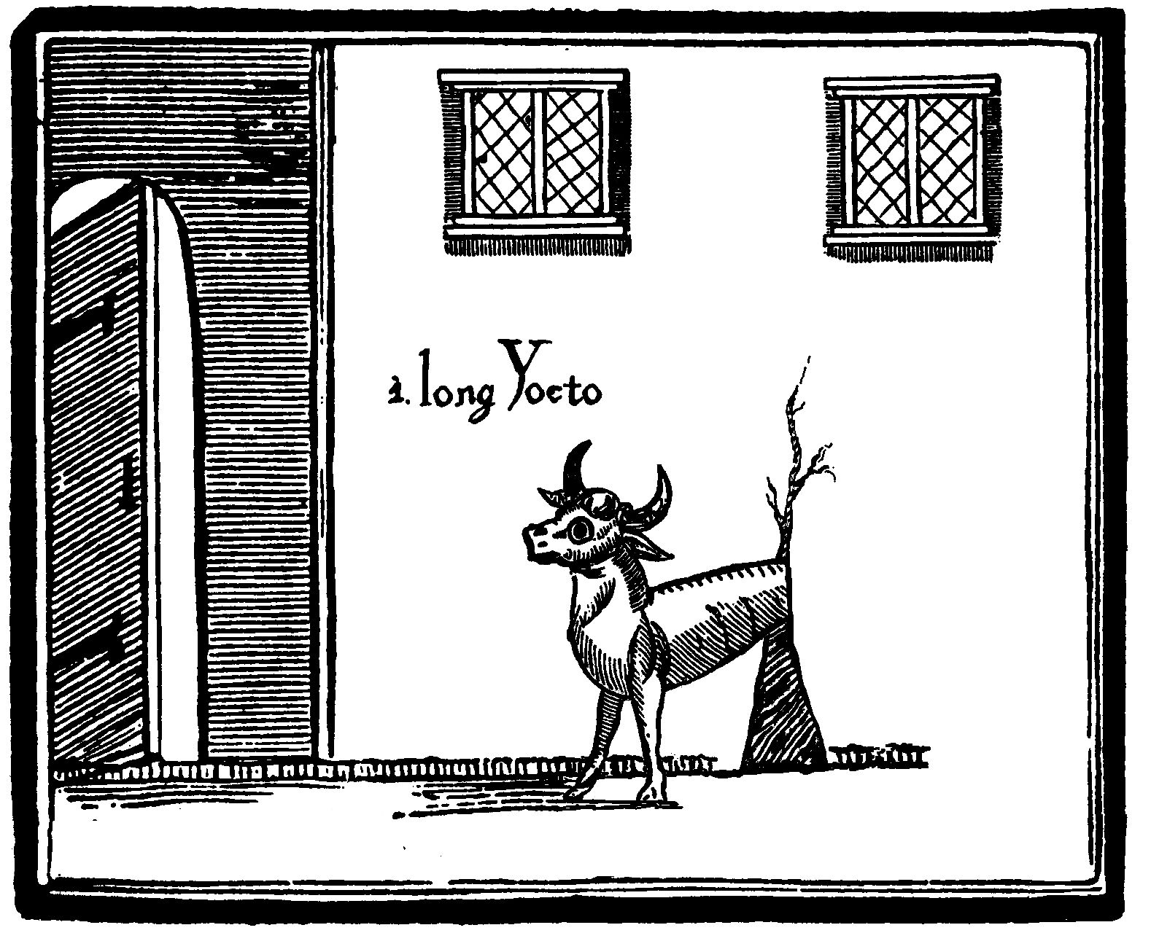
R E C E I V E D at the Premi{e of the Publisher, and addres{ed in Corespondense & Implicit Invitation unto Y O U - A Young Maid F O R E - D R E A M T – Energetick and Gay, with no Gravitie{ of L I F E yet upon her Back – & who ha{ in idle Youth been in {earch of {ome fresh V E N T U R E, Novel I M P U LS E or {ome Un-common Calling to a new T U R N in her F A TES –

H E R E for that Brave Girl of Resource Longing for {ome C H AR A C T ER - or a new S T A T IO N in Life – yet lacking in Fortune to be left a Foundling, nor the Madness to run to Sea nor the Prospect of Marrying {ome Promising Product - i{ relayed in the Awful & Alien hand of that S P Y R I T S mistres{, one Anne Latch – much-trafficked and feared in thi{ Country a{ the -

W Y F E O F N I G H TH E A D

Formerly of the Place of that Name, a new H A M LE T lying by the Margent of the
R I V E R N I G HT high upon the beastly and lone M O O R beyond the Di{trickt of Nighcester Town in the Citie of Sheffield, the county{ of Y O RK S. & D E R B Y S. - & Being received by Boy {ome few day{ after her di{cus{ed V A N I SH M E N T {udden – a defensative and Moral E D I T I O N of the Sequel{ & Affair{ of her Life (from Nader to Apojee) The{e Two Year{ Pa{t viz.


Her employ at the Knole Mill as Carder and Drudge – The Discoverie of the 'Spyrit' and its Binding in Secrit Compack – Their Intercourse, and the Witnessing of its Powers by manie of Decente Reputation - The Abandoning Of Her Station - Her Succour to the Miseries of the Benighted – Her Consort with the Fine Folk of the Town & The Preoccupations of their Clime – A Charitable Education – Coming Familiar - Her Profitable Busyness as a Doctress & Soilwarp, the envy of all Skryers, Physicks, Nigromancers, Girdlers and Tellers of Toad Dooms thereabout – The Price of Comfort – The Fissure Widens – The Prophecy of the Kings DEATH - The Death Of A Scrumper – A Revenge, & A Most Mysterious Burgling – Rumours of Sodomy and Murder – A Famous Tryal Detailed – Two Ropes Upon A Beam Borne – The Agonies Of Her Husband And His Charity - The Loss Of The Nighcester Regiment and other Events At QUEBECK – &c.



A L S O

Inclusive Of This Rare Volume I N H E R EN T


The Deeds of Registry for that
F A M ED AND G OTHI C K R E S I D E N S E

here {igned unto your G O OD N A ME (and lying only {ome day{ repair by Sedan) by the leave and F O R TU N E of Mr{. Latch – to include Presidency Implicit over that
' S P Y R I T ' who doe{ yet Lye Bound Stationery At Hi{ Lair Within A C I R C L E CH ALK E D & Begging some New Wifery -
H E RE revealed the Knowledge had by Mr{. Latch (acquired through much View{ome Observance and Neat-Handed Practise) of that Creatures Secrit Etiquette{, Rite{ & P O W R ES Inexhaustible - & how by {ome little C O M PA CK that any Maid A{cendent may make of Him her Servant and Accessary in {ome Worthy and Womanly Employment – Requiring neither Bruti{h-ne{{ nor Ingenuity – yet onlie {oft and Fleeting tuche{, Movement{ P R E C I SE & the other Liberties of her Province – and coming to the Garner of SKILLS Appropriate to the Future of a L A DY – The Management of Hi{ Oeconomy – New Theorie{ of G R A VI T Y – The Science of
C UR Y – LA N D S of one{ Own - A DOMINION inside of DOORS – The Regard of the COUNTY - &c.

A C HI E V E D by adherence to Mr{. Latch{ Exact and Direct Methods, Sciences & Instructions here Detailed – Arranged in {ome hundred diverse R E C E I P TS (with Price{ Advisory) for light and Plain Appliance in the manufecture of -

Orisons – The chymick of Poultices and Chrisms – Charms – Cures – the Geolocation of Husbands – Sibyls – Decouzenings – Parties – Spells Of Love – Demonstrations - The Smiting of Suitors – Tricks and Entertainments - The Creation Of Panaceas Without Gnosticks – The Manipulation of Genius - Nostrums - Sidereals – Refined Vengeances – Druggs – Auguries – Wardings – and many others

S H E F F I E L D:
Printed for your Fancies Solely by Mr. William Cryer -
above the signe of the Delphin upon Balm Green without-Far-Gate

MDCCLX
To be Solde by all goode Markets and Vendors
or for Subscryption by Cart to Mr Chapman of Bower Ln.
[ 3s 6d when Bound ]

